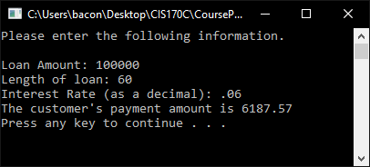

Processing a loan (I verified with a loan calculator that the above calculation is correct)

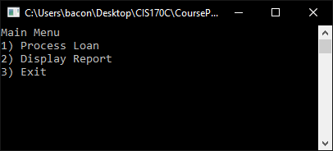

Main Menu

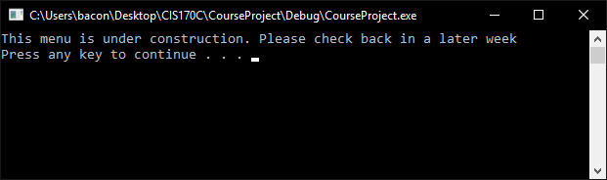

Display Report Menu